SOLUTION OF HOMEWORK 04
1.
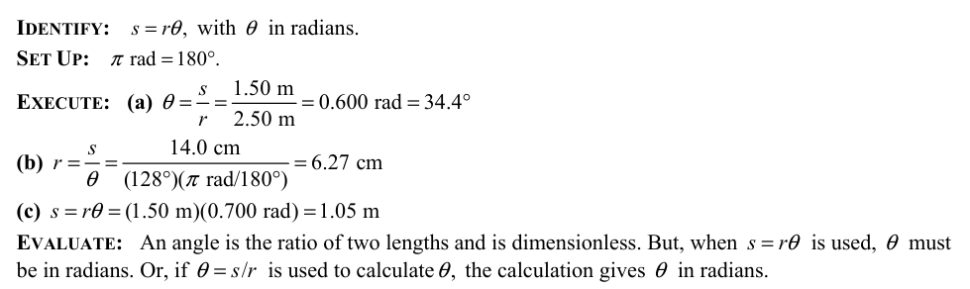
2.
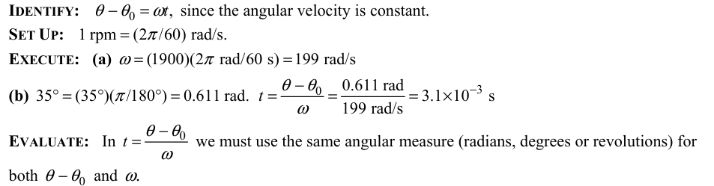
3.
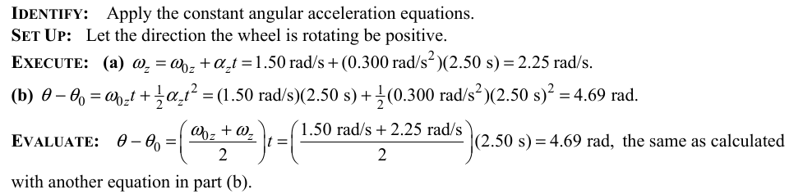
4.
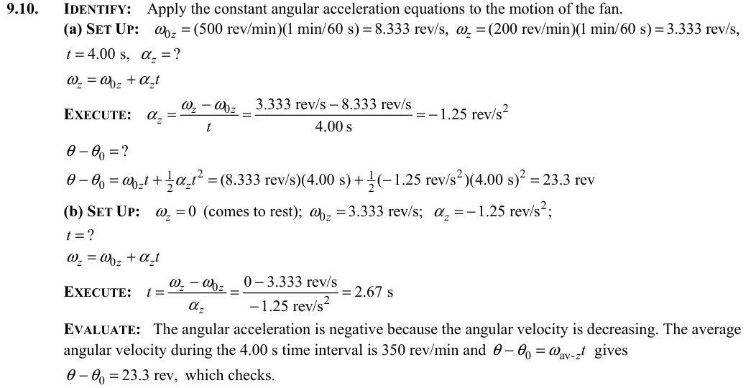
5.
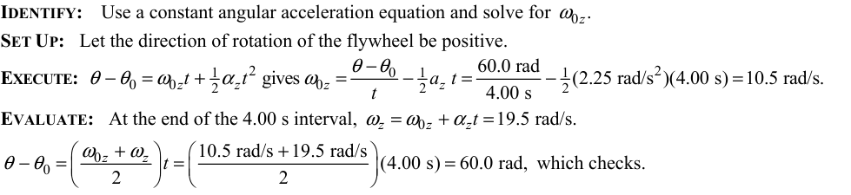
6.
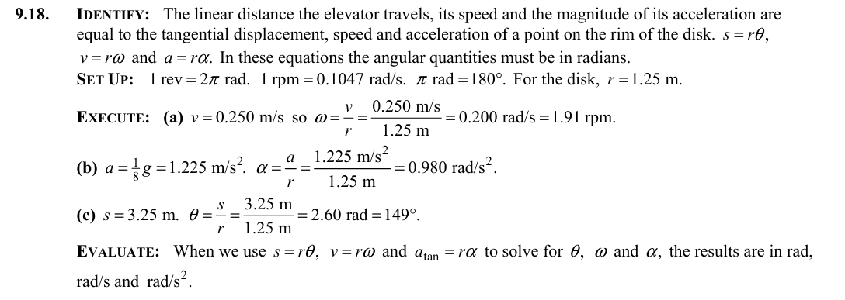
7.
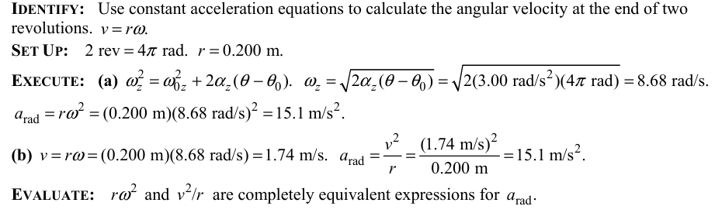
8.
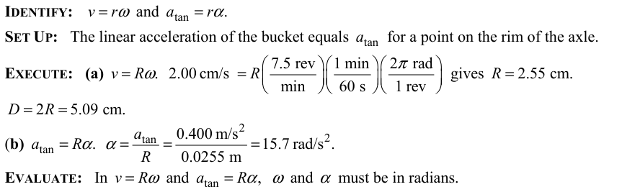
9.
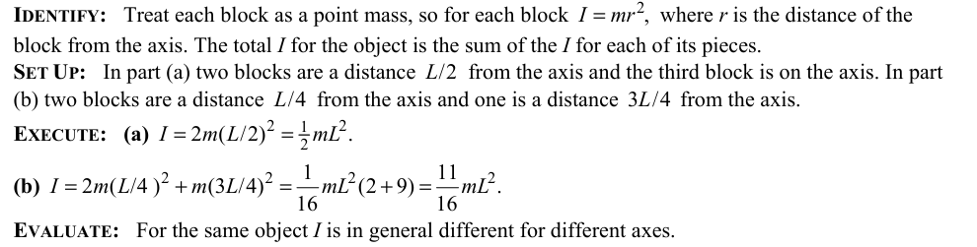
10.
